

Project Report

On

**Online Attendance Management System**

Bachelor of Computer Application



Saurashtra University

Developed By

Anand Kothari

[BCA Semester 6]

College Name

Bhavan’s Shree H.J.Doshi IT Institute, Jamnagar

[Affiliated to Saurashtra University, Rajkot]

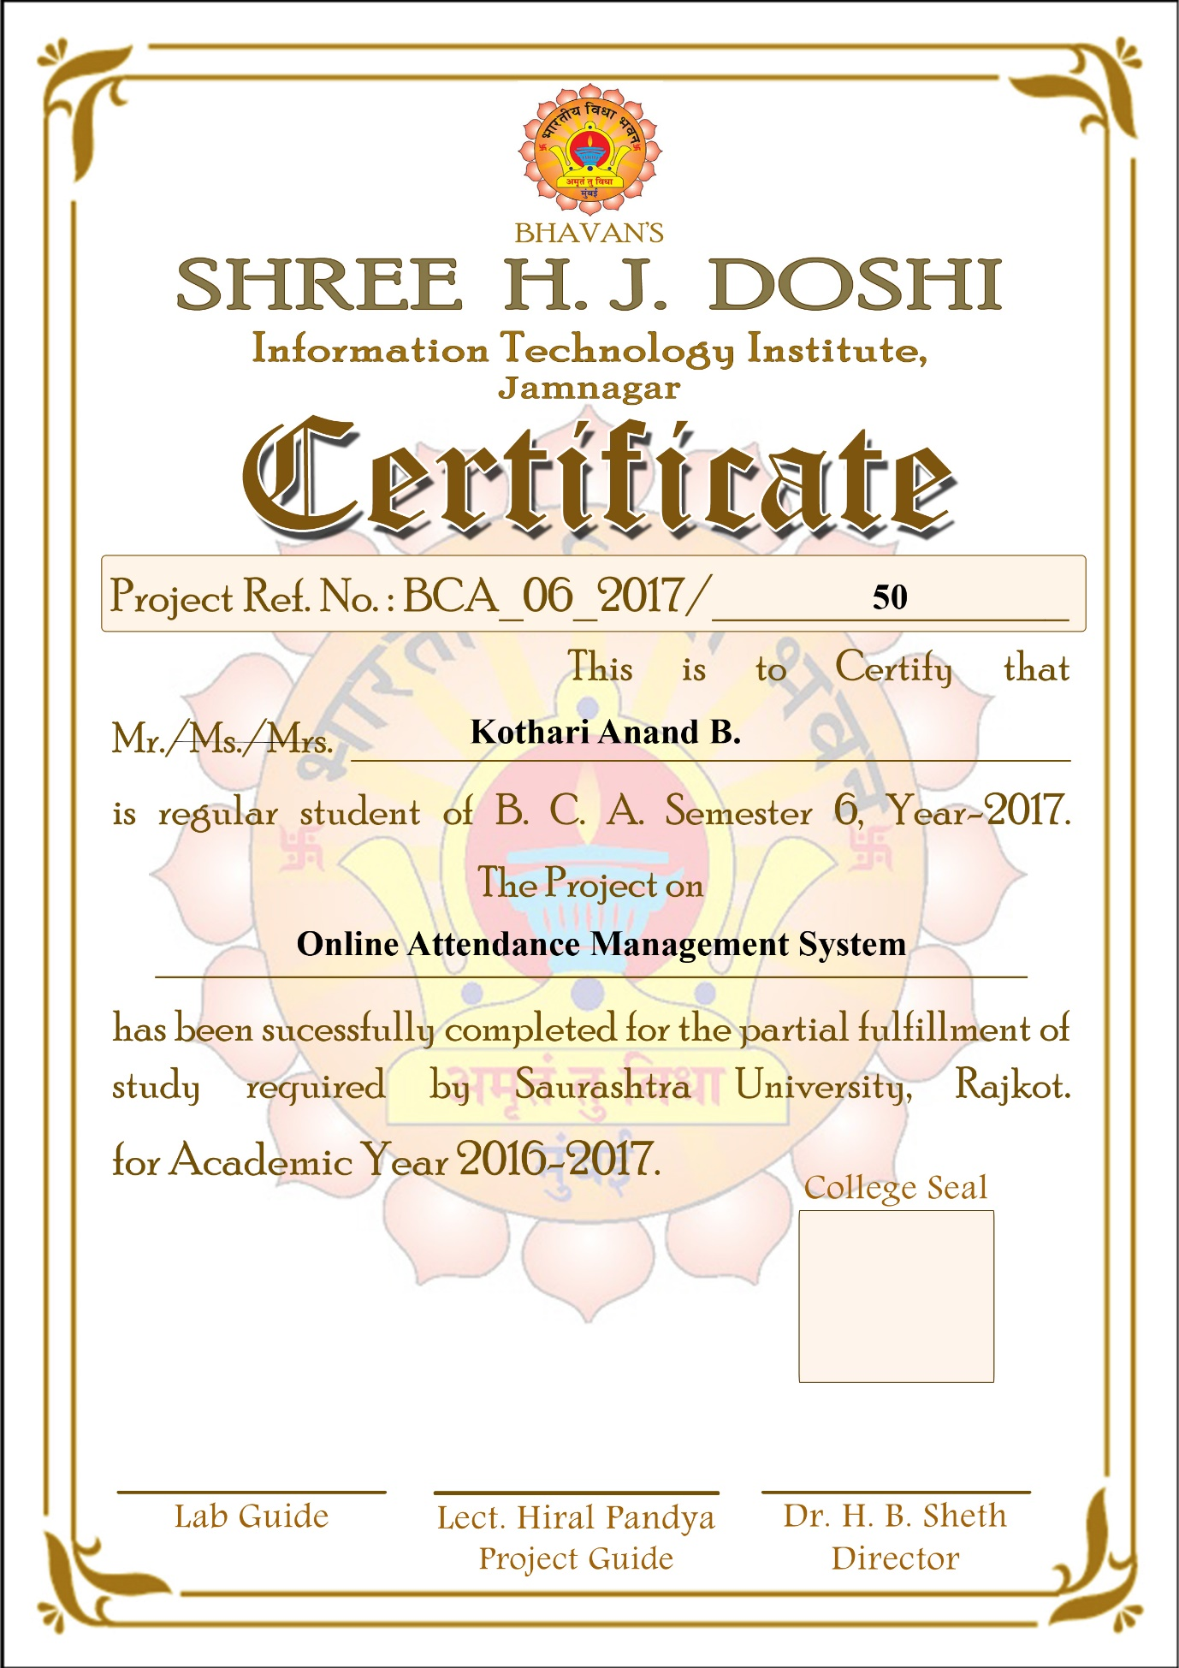

Abstract

My project is on “Online Attendance Management System” which was named as “inWork”. The aim of my project is to provide an Online system for Staff Attendance and the maintenance of Staff Attendance records in a more easy & convenient way.

In this highly competitive world where everything is going for Online, information accessing has become quite easier comfortable and convenient.

In inWork there are various modules which are necessary for the online staff attendance management are as follows:

* Admin add new staff with all its required information and along with that admin can upload the staff image and its documents.
* Admin assign username and password with IN Time and OUT Time of staff.
* Admin add attendance of staff and also add new designations and leave types.
* Staff view his basic information and details of his attendance.
* High security is provided to Admin & Staff Account in the system so that information & data cannot be manipulated by the outsiders.

Acknowledgement

I feel great pleasure in submitting this project report as a part of BCA student, a practical study plays an important role. This project is online based.

I fall short of words to pen down anything for support & encouragement extended by our parents through the completion of this project a mere thanks is little for their love, encouragement and support.

I am thankful to H.J.Doshi Information Technology Institute & Bhavan’s Shri A.K Doshi Vidhyalaya for providing me the project information.

I would like to thank my college support extended for the timely completion of this project. Her guidance, suggestions and expertise have been a source of inspiration and helped in refining my thinking and approaches during the project tenure.

Also my deepest gratitude goes to the respondents for her active cooperation and my dear friends to have great support all throughout. Last but not the least we would like to thanks all my friends and faculty members who maintained a friendly relation.

**Yours Faithfully,**

Kothari Anand

Index

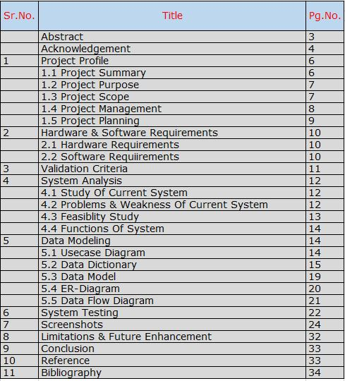

**[ 1 ] Project Profile**

[ 1.1 ] Project Summary

This is an Online based project named “inWork” is an Online Attendance management system specially designed for college staff members. There are various functionalities of the inWork which are as follows

* Add new staff with basic, professional, educational information.
* Assign username & password along with the IN Time & OUT Time to the staff.
* Upload staff images and staff documents
* Add daily attendance of the staff and display attendance.
* Add New designations and view of all designations
* Add New Leave Type and view of all Leave Types
* Display staff information with its attendance to the staff.

[ 1.2 ] Project Purpose

*“Nothing Is Permanent But We Can Change.”* How true these Words are, especially when we look at the world of Computers. Computer Technology is growing so fast that every field has to keep abreast of times. Nowadays everything is online. As my system “inWork” is designed with user-friendly, I have given system with proper validations with error messages

[ 1.3 ] Project Scope

My project is on “Online Attendance Management System” which was named as “inWork”.Admin add new staff with all its required information and along with that admin can upload the staff image and its documents.Admin assign username and password with its staff IN Time and OUT Time.Admin add attendance of staff and also add new designations and leave type. Staff view his basic information and details of his attendance. High security is provided to Admin & Staff Account in the system so that information & data cannot be manipulated by the outsiders.

[ 1.4 ] Project Management

“Management” is a very necessary activity when computer based systems and products are built. Project management involves the Planning, Monitoring, and Control of People, Process, and Events that occur as software evolves from a preliminary concept to an operational implementation.

Project management is not an exact science. Effective project management calls for good qualitative judgment and decision taking capabilities. In addition to having a good grasp of latest techniques of software project management such as Cost Estimation, Risk Management, Configuration Management, and Scheduling, project managers also need good communication skills and the ability to get work done. Useful techniques for time & effort estimation do exist. And because estimation lays a foundation for all other project planning activities, and project planning provides the road map of successful software engineering

[ 1.5 ] Project Planning

Project planning consists of the following important activities:

* Effort, cost, resource and project duration estimation
* Risk identification, analysis and abatement procedures

An important task performed during the project planning stage is the selection of a suitable development model. We are developing Business Management System which is based on application model.

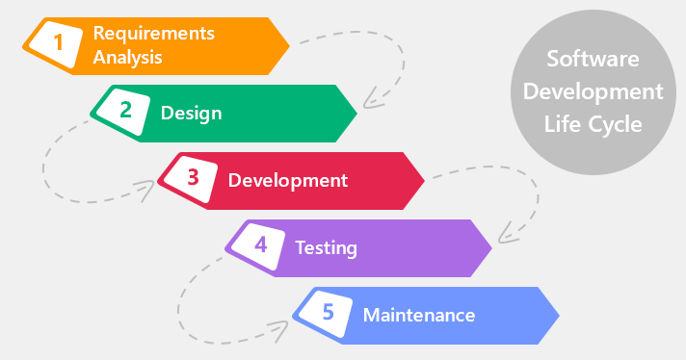

[ 2 ] Hardware & Software Requirements

[ 2.1 ] Hardware Requirements

* Computer with Intel Pentium 4 or above Version Processor.
* 150 G.B. Hard Disk or Above Capacity.
* 1 GB RAM or Above Capacity.

[ 2.2 ] Software Requirements

* Microsoft Windows XP OS minimum.
* Microsoft Visual Studio 2012.
* Microsoft .NET Frame Work v4.0
* Microsoft SQL Server 2012.
* Microsoft Office 2013



[ 3 ] Validation Criteria

One of the most important phases of project management is known as validation. The process of validation generally occurs as one step or multiple steps of the process, usually in stages and is used to determine if the project is meeting specifications. The specifications of the project are highly detailed, and it is up to the project manager to evaluate the validation process to be sure the project is meeting the requirements. Experience in project management can assist supervisors in evaluating the different phases and steps of validation. Where validation is the technique to evaluate the stages of the project, verification is the proof of compliance made by the project manager. This proof can be in the form of certification, or can be as simple as different area supervisors signing off on the phase of the project.inWork is an online attendance management system also has various validation to stop the invalid format input of information’s, so incorrect data should not be inserted in the database. Here various advanced .NET Validation controls are used in the inWork.

[ 4 ]System Analysis

[ 4.1 ] Study of Current System

The existing online attendance management system has been used for approximately 2 years, and it is insufficient because system has different disadvantages. Its user interface is also not proper. Due to online it has slow speed, it takes more time to make an entry for the attendance records. The existing system has no any security purpose for the admin and staff security. No any functionality on staff leave.

[ 4.2 ] Problems & Weakness of Current System

* It is not secure with username & password.
* It cannot maintain staff information effectively.
* It has not functionality for staff designations and leave
* It has not proper UI (User Interface).
* System slows down if any error is generated.
* It cannot maintain attendance properly.
* Data are not stored properly due to invalid data inputted.

[ 4.3 ]Feasibility Study:

We were given the project to develop such a totally computerized system which is helpful to the person who is responsible to manage all the information of business.

The old system is very much time consuming and so much manpower is wasted in this system of working. In short, the feasibility study tries to anticipate future scenarios of system development.

The following aspects are considered in the feasibility study:

* Operational Feasibility:

On studying the operational feasibility of the project, the following conclusion could be derived:

Development system will provide the adequate throughput and all necessary information to the end user. It will provide advantageous and reliable services.

* Technical Feasibility:

Technical feasibility tries to answer the following question to make the system feasible to develop: Can the work for the project be done with current equipment, exiting system technology and available person?

The software or tools necessary for building or running the application were easy available within our organization. We have used Microsoft ASP.NET as Front End and Microsoft SQL Server 2012 as Back End tool.

* Economical Feasibility:

Economical feasibility addresses to the following issues:

Are there sufficient benefits in creating the system to make the cost acceptable?

If we count the benefits of developed system then it is very much economical in the terms of time and manpower saving. Hence, it is very much feasible in cost saving also.

[ 4.4 ] Function of the System

Functionalities of Combuss are as follows:-

* Add new staff with basic, professional, educational information.
* Assign username & password along with the IN Time & OUT Time to the staff.
* Upload staff images and staff documents
* Add daily attendance of the staff and display attendance.
* Add New designations and view of all designations
* Add New Leave Type and view of all Leave Types
* Display staff information with its attendance to the staff.

[ 5 ]Data Modeling

[ 5.1 ] Use Case Diagram

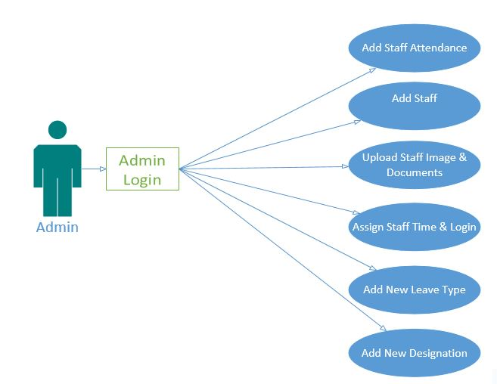

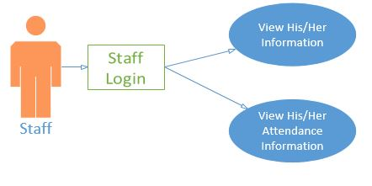

[ 5.3 ] Data Dictionary

Data is the key to the overall system design and must be structured to meet the user requirement. The collection of structured data builds up data dictionary, which is an important tool in data flow analysis. The complete set of data definitions provides the basis of the data dictionary. It facilitates cross-referencing and assessment of the implication of changes. Each data item is uniquely identified by its definitions but referred by different name at different tables.

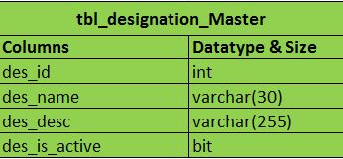 PK: des_id

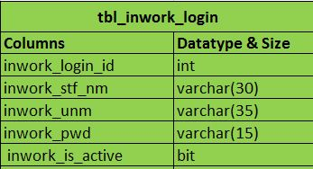 PK: inwork_login_id

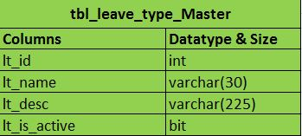 PK: lt_id

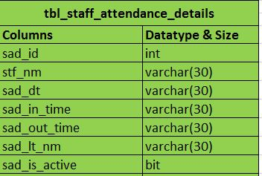 PK: sad_id

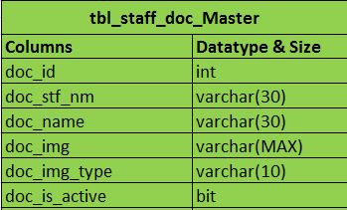 PK: doc_id

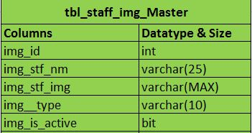 PK : img_id

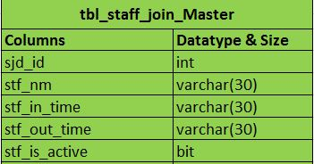 PK: sjd_id

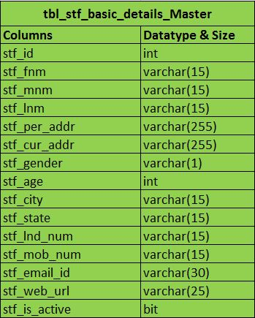 PK: stf_id

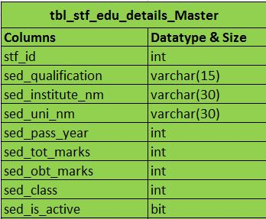 FK : stf_id

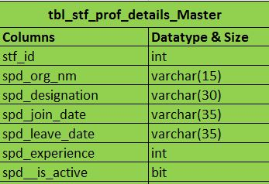 FK: stf_id

[ 5.4 ] Data Model

[ 5.4.1 ] Entity Relationship (E-R) Diagram:

Any information system description must start with their entities-people, places and things. These entities interact with each other in various ways and those interactions are called Entity Relationship. In system analysis entity relationship analysis is one of the conceptual modeling methods.

The E-R data model uses a few basic concepts in Producing E-R Diagram, they are:

* Entity:

An entity is a person, place or thing in an enterprise e.g. an employee, a student, a project; an order etc. Similar objects or things are grouped into entity sets.

* Relation:

A relationship is meaningful association or linkage or connection between entities.

* Attributes:

An attribute is an aspect, quality, and characteristics, description of either an entity or a relationship. An attribute tells what an entity is, entity has entity contains or the entity does.

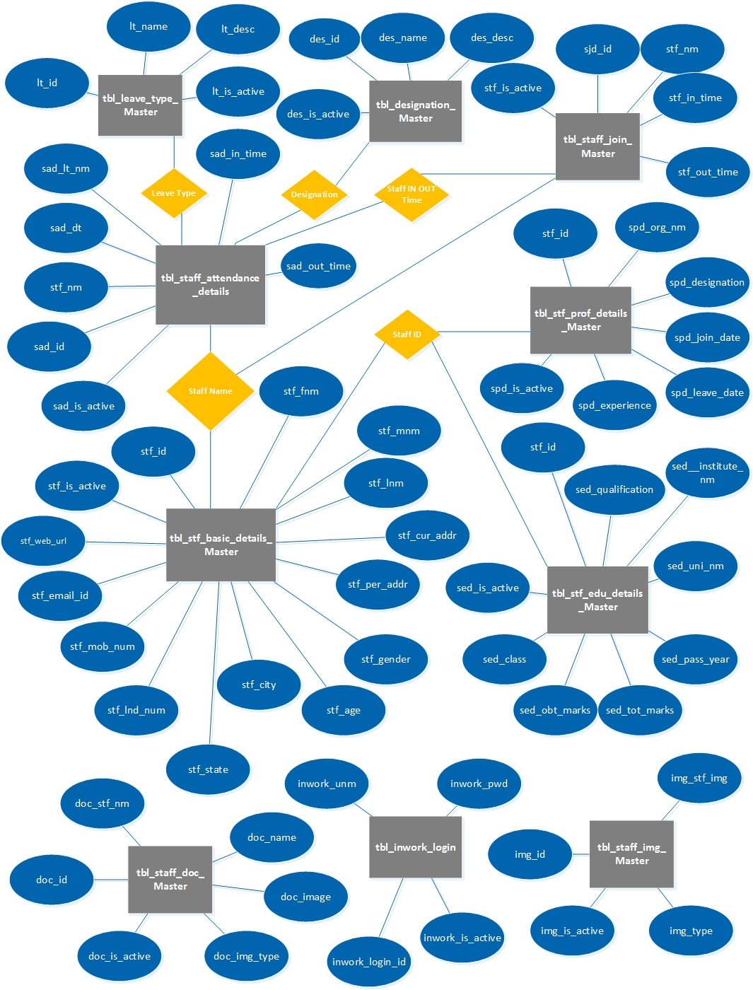

[ 5.5 ] Data Flow Diagram

**Context Level DFD :-**

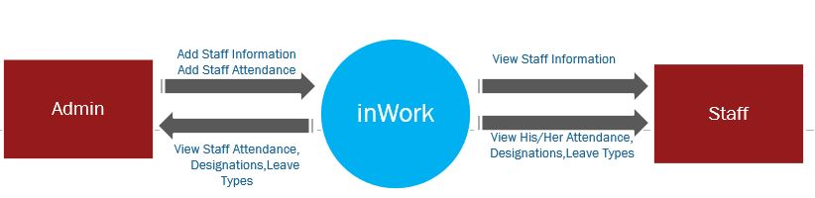

**Level 1**

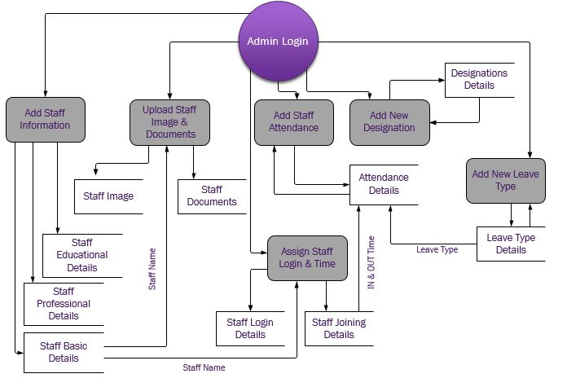

**Level 2**

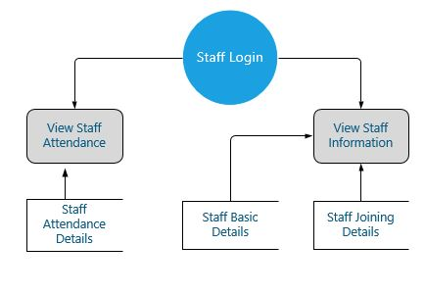

**[ 6 ] System Testing**

**“Testing Is The Unavoidable Part Of Any Responsible Effort To Develop Any System.”**

Testing is the process of executing a program with the intent of finding an error. A successful test is one that uncovers an as-yet-undiscovered error.

* Exercise the internal logic and interfaces of every system component
* Exercise the input and output domains of the program to uncover errors in program function, behavior, and performance

Our objective is to design test that systematically uncover different classes of errors and to do so with a minimum amount of time and effort.

Testing Methods:

*“A Good Test Should Be Neither Too Simple Nor Too Complex.”*

After determining testing plan and testing strategy, appropriate method for system testing should be applied. Any system can be tested in one of two ways:

* **White - Box Testing:**

White Box Testing, sometimes called Glass-Box Testing, is concerned with the implementation of the program. This type of testing of system is predicted on close examination of procedural detail.

The purpose is to exercise or try out different programming and data structures used in the programs. This test concentrates on the examination of the code rather than the specification.

* **Black - Box Testing:**

Black-Box Testing, also called Behavioral Testing, focuses on the functional requirements of the software. The Black-Box testing is not an alternative to White-Box techniques.

Black-Box Testing attempts to find errors in some categories such as, Interfaces errors, Incorrect or missing functions, Errors in data structures or external database access, Performance errors, Initialization and termination errors.

**[ 7 ] Screenshots**

Login Screen

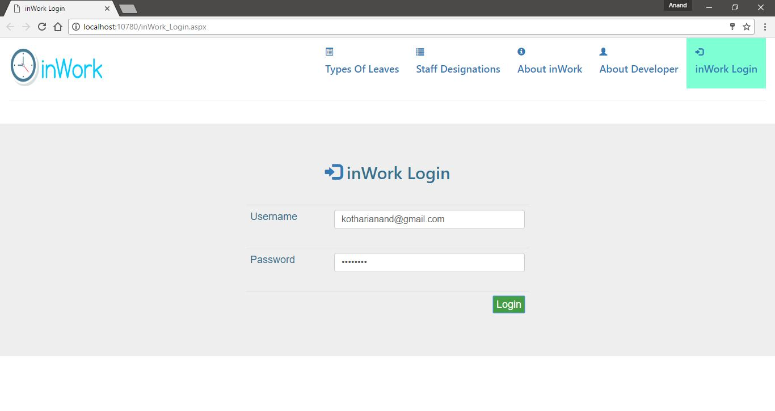

Add New Staff

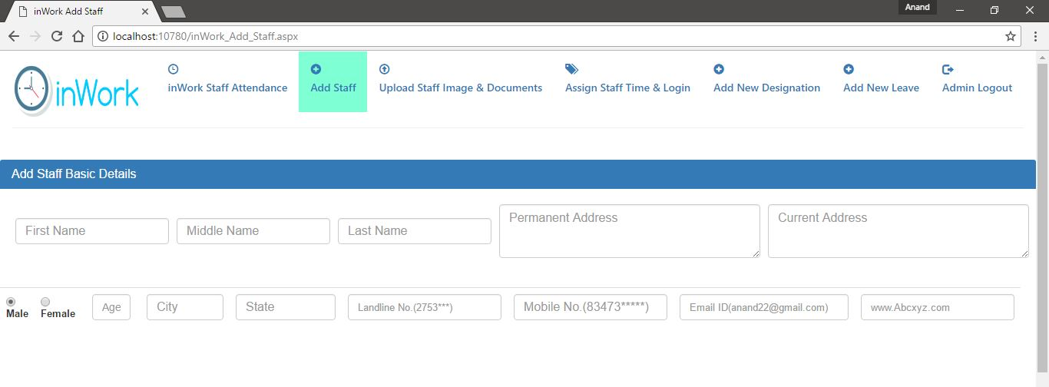

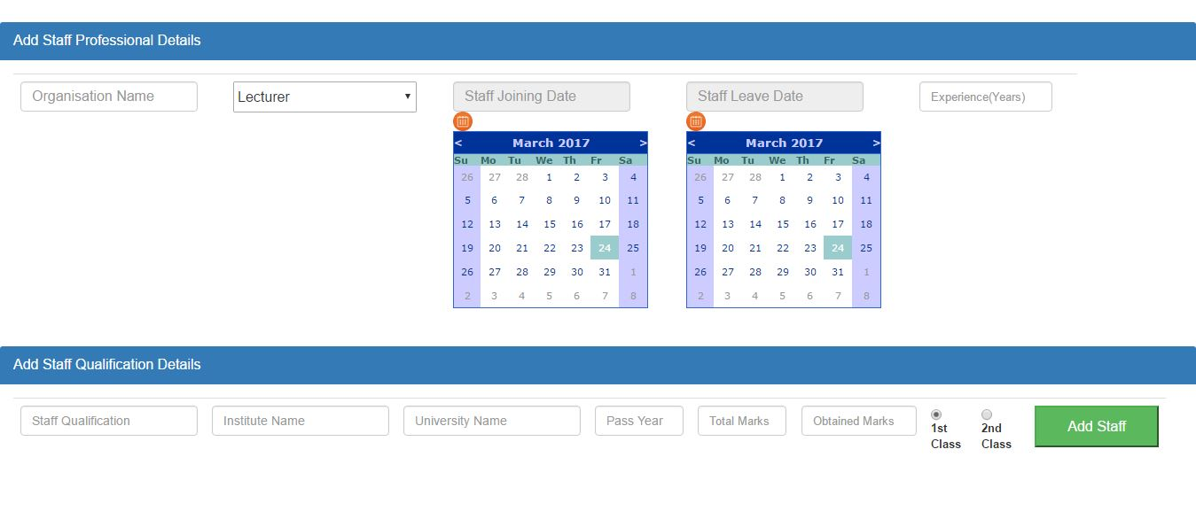

Upload Staff Image & Document

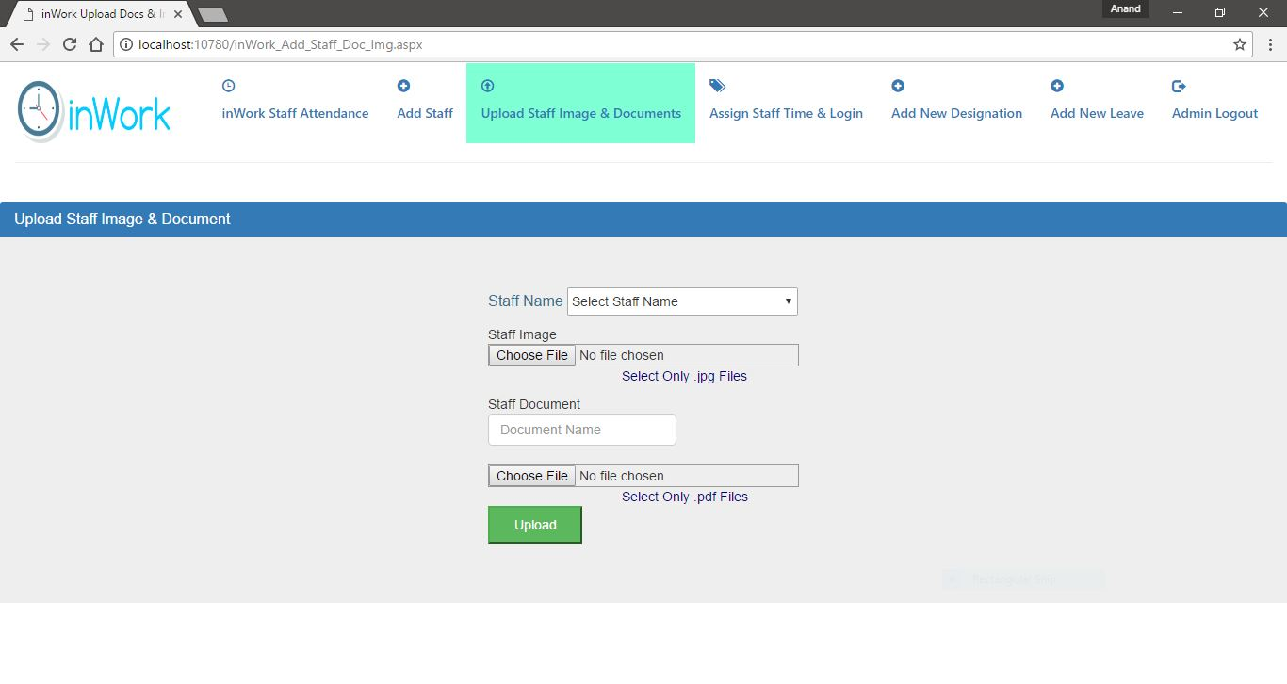

Assign Username Password & IN OUT Time

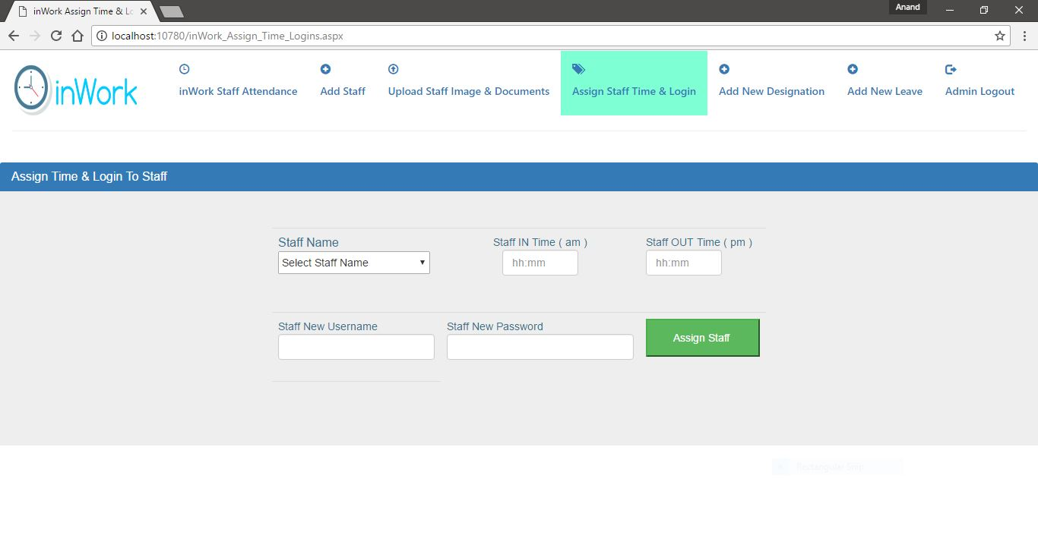

Add Staff Attendance

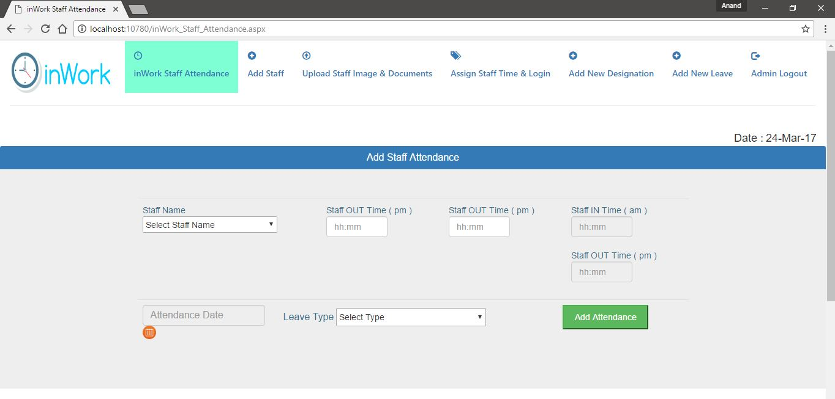

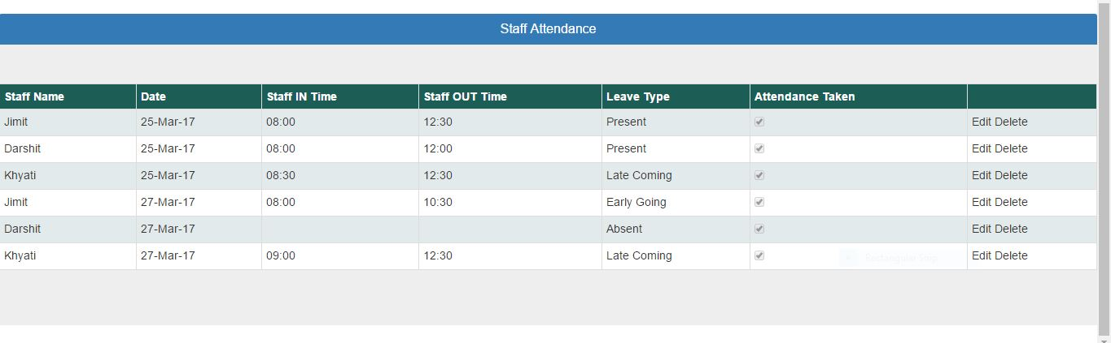

Add New Designation

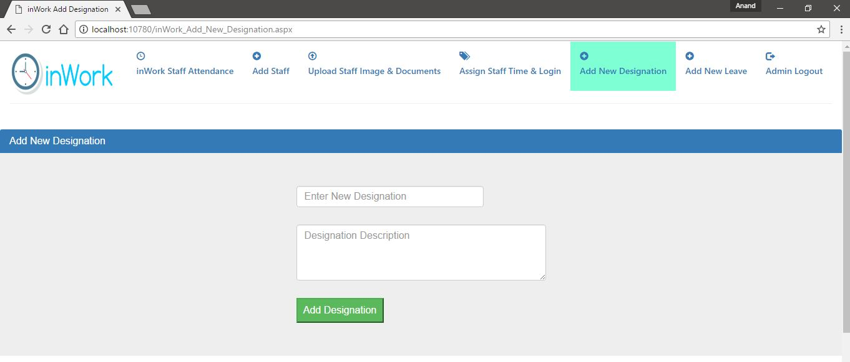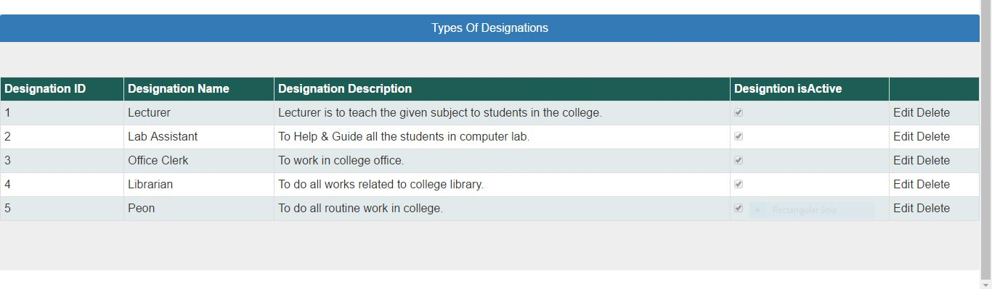Add New Leave Type 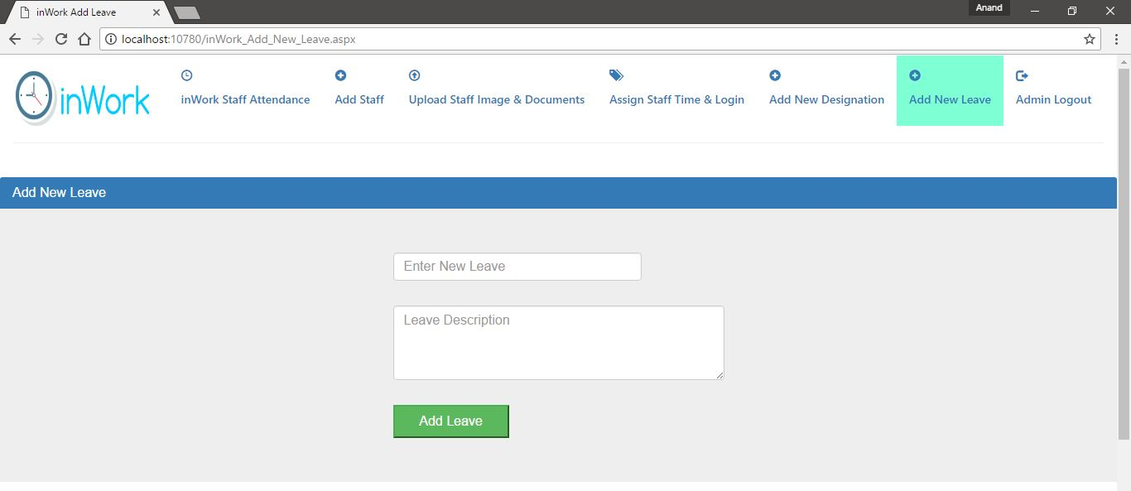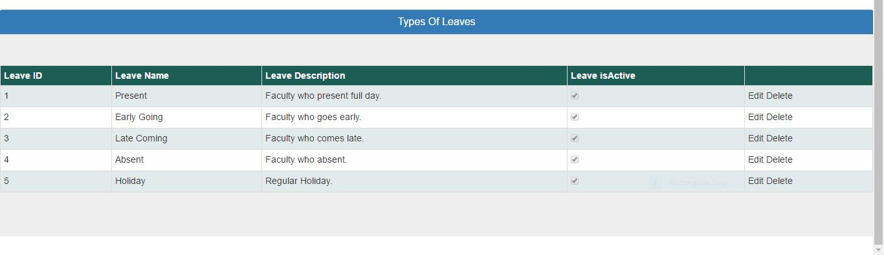

Staff Information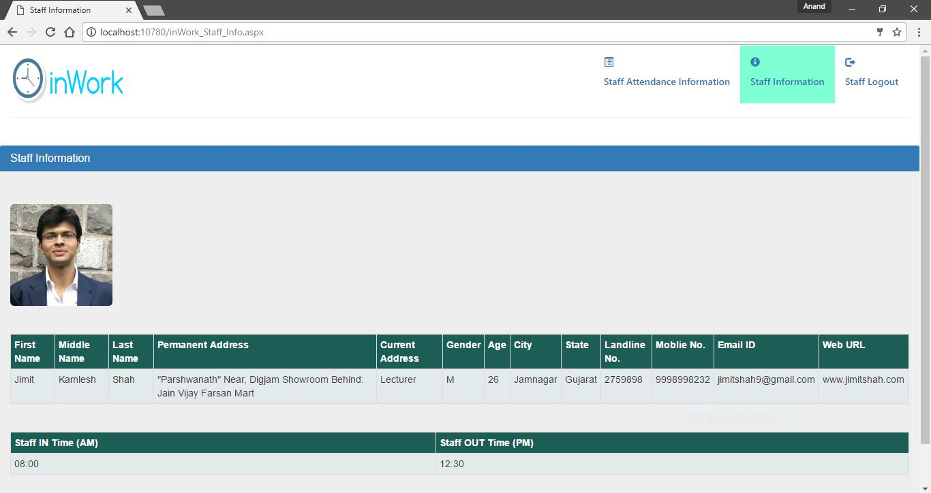

Staff Attendance Information

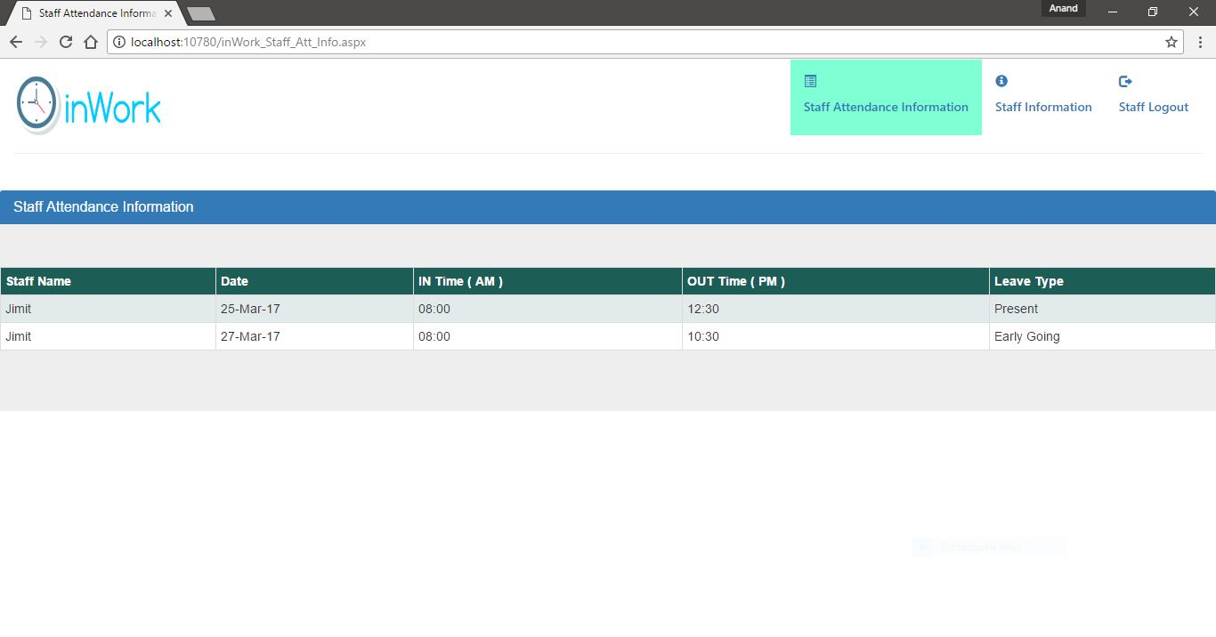

Types Of Leaves

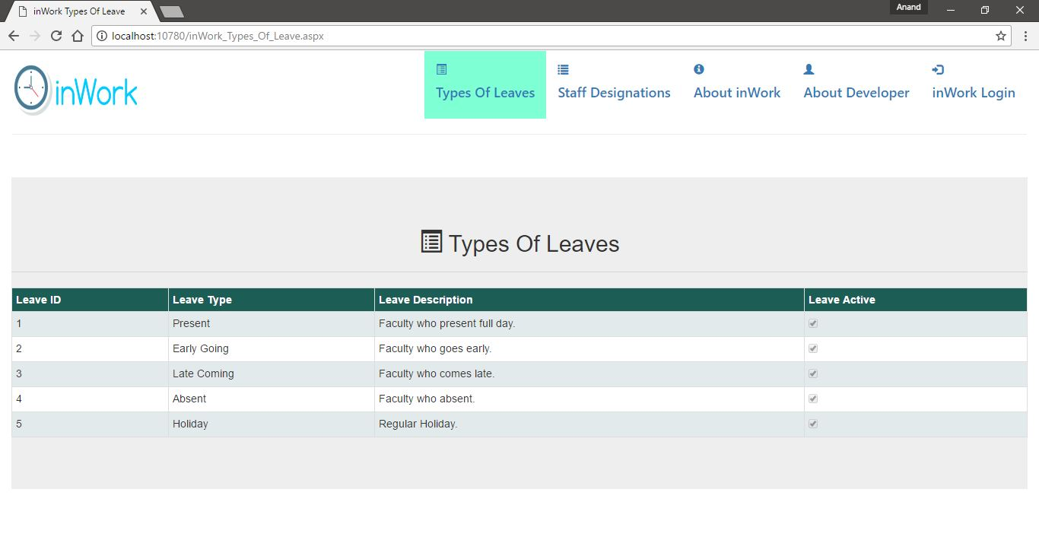

Types Of Designations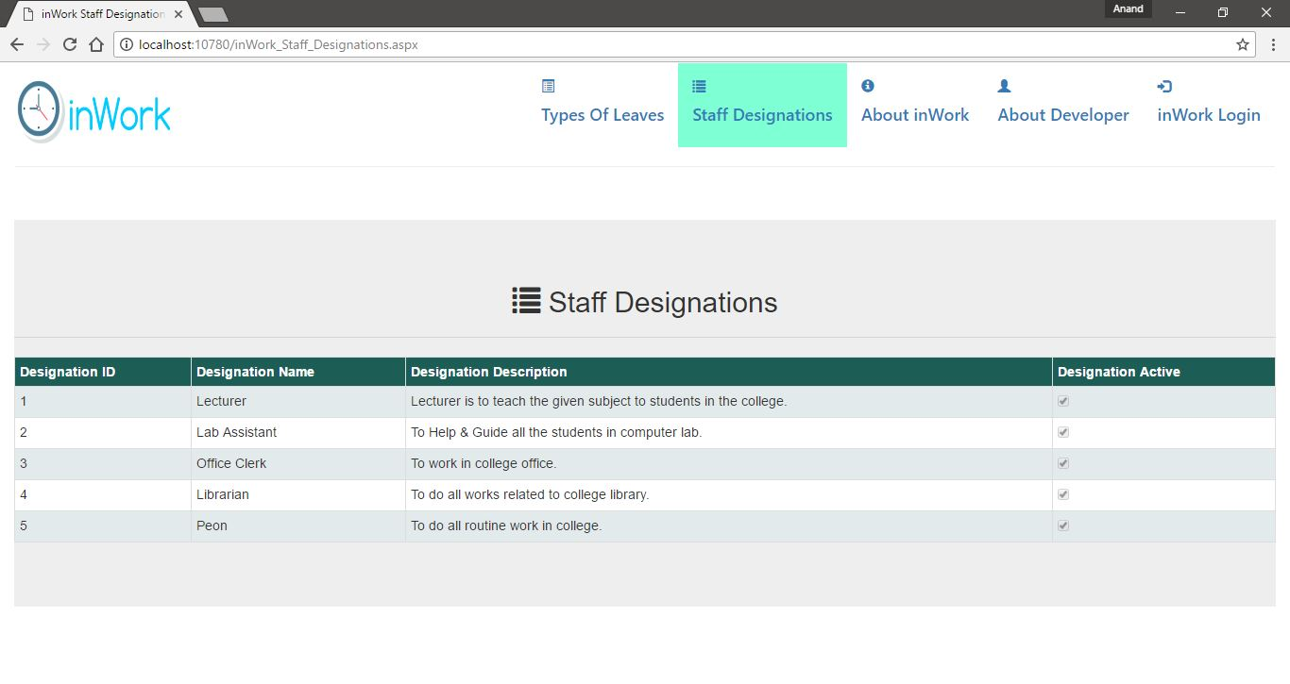

About inWork

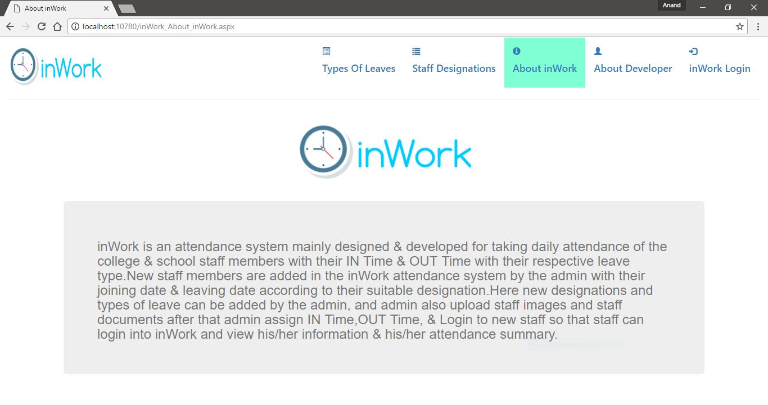

About Developer

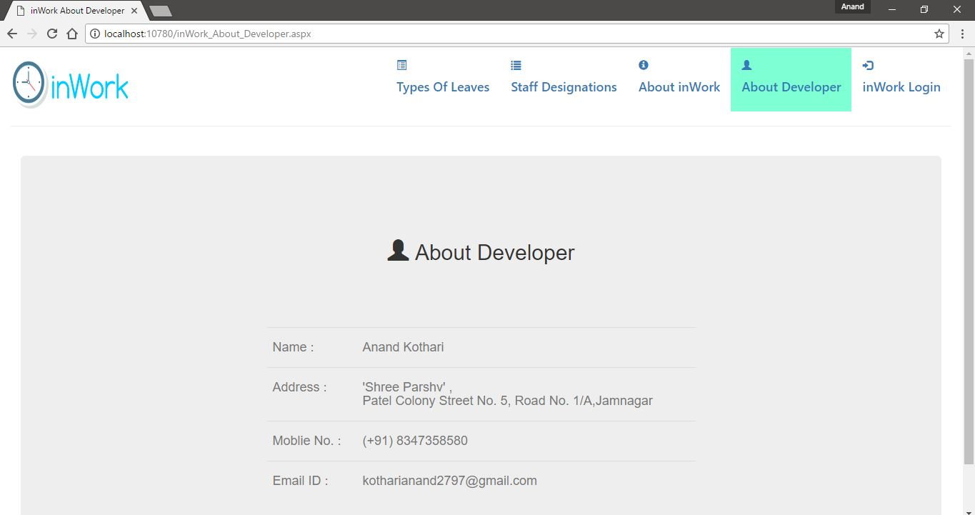

**( 8 ) Limitation and future enhancement**

( 8.1 ) Limitations of system

* No reports are generate.
* Cannot search Attendance date to date.

( 8.2 ) Future enhancement

* Generate Daily Report.
* Notify Staff about remaining leaves of staff.
* Expand inWork with students attendance.

**( 9 ) Conclusion**

**Attendance is the concept of people, individually or as a group, appearing at a location for a previously scheduled event. Measuring attendance is a significant.**

**inWork is an Online Attendance Management System which is developed for the college staff member for their daily attendance with various functionalities.**

**( 10 ) Reference**

** **



**( 11 ) Bibliography**

* **Professional ASP.NET 2012**

**[AUTHOR =** Morgan Skinner, Karli Watson**]**

* **Introducing Microsoft SQL Server** 2012
* **System analysis and design 9th addition**

**[SHELLY CASHMAN SERIES]**

**[AUTHOR =** Gary Shelly, Harry Rosenblatt**]**

